

database management systems

(Slot-d2)

LAB ASSIGNMENT-2

Name: **VIBHU KUMAR SINGH**

Reg. No: **19BCE0215**

Teacher: **Nancy Victor**

**Q)Create a table "student" with the following attributes:**

1. **register number-> primary key**
2. **first name-> not null**
3. **last name**
4. **Qualifying marks-> greater than 50**
5. **email id-> unique**
6. **nationality -> India, USA**
7. **age-> between 18 and 22**

create table student(

s_regno int primary key,

s_fname varchar2(20) not null,

s_lname varchar2(20),

marks number(2) check(marks>50),

email_id varchar2(20) unique,

nation varchar2(20) check(nation in ('India','USA')),

age number(2) check(age between 18 and 22)

);

**SCHEMA:**

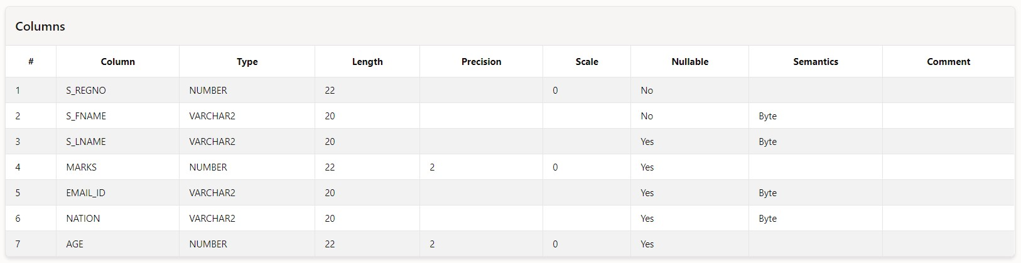

**Q)Add rows to the table, try adding rows that doesn't satisfy these constraints. Take the screenshot of the error message.**

insert into student values(1,'Vibhu','Kumar',65,'vibhu@gmail.com','India',19);



insert into student values(2,'Avnish','Tiwari',40,'vibhu@gmail.com','India',19);

**ERROR MESSAGE:**

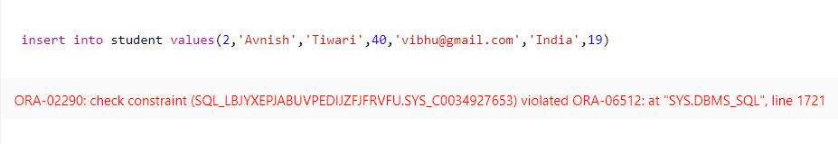

insert into student values(2,'Avnish','Tiwari',70,'Avnish@gmail.com','USA',20);



insert into student values(2,'Anamaya','Vyas',95,'Anamaya@gmail.com','India',20);

**ERROR MESSAGE:**

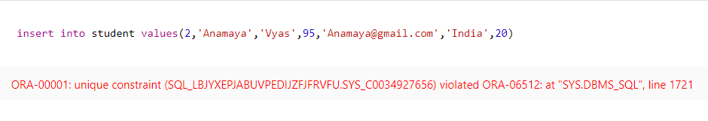

insert into student values(3,'Anamaya','Vyas',95,'Anamaya@gmail.com','India',20);



insert into student values(4,'Aditya','Chaudhary',80,'Aditya@gmail.com','Pakistan',20);

**ERROR MESSAGE:**

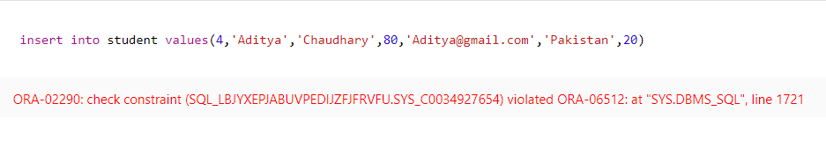

insert into student values(4,'Aditya','Chaudhary',80,'Aditya@gmail.com','USA',20);



insert into student values(5,'','Jain',85,'Atishay@gmail.com','USA',21);

**ERROR MESSAGE:**

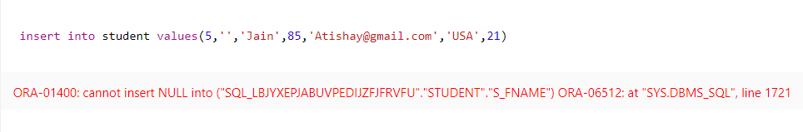

**Add few rows with age as 20, add few rows with qualifying marks greater than 90, add few rows with the nationality "USA".**

The following rows were inserted:

insert into student values(5,'Atishay','Jain',85,'Atishay@gmail.com','USA',21);

insert into student values(6,'Yash','Jain',55,'Yash@gmail.com','USA',19);

insert into student values(7,'Khushi','Gupta',99,'Khushi@gmail.com','India',19);

insert into student values(8,'Arnav','Batla',91,'Batla@gmail.com','USA',21);

insert into student values(9,'Ishika','Dahake',51,'Dahake@gmail.com','USA',20);

insert into student values(10,'Atharva','Agarwal',98,'Atharva@gmail.com','USA',19);

**DATABASE:**

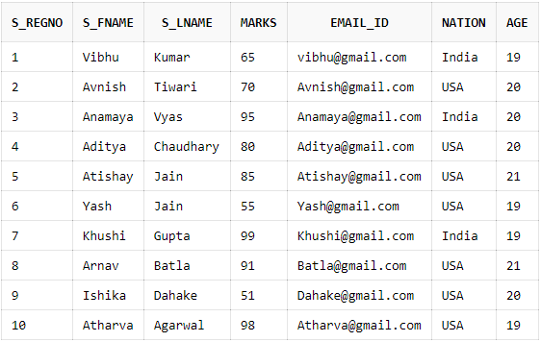

**Select the details of students whose age is 20:**

select * from student where age=20;

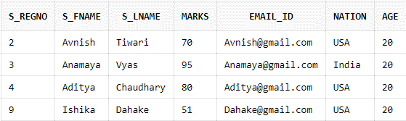

**Select the register number and name of those students whose qualifying marks is greater than 90:**

select s_regno,s_fname from student where marks>90;

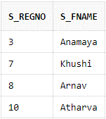

**Select the register number and email ids of students from USA:**

select s_regno,email_id from student where nation='USA';

